PACKING LIST
ADVENTURE PADDLE 2026

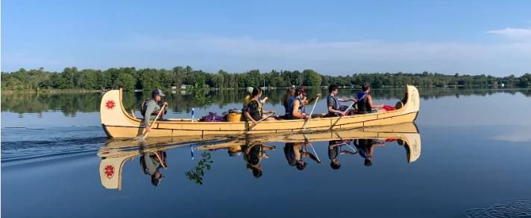
Our canoes are VERY FULL during the trip.
PLEASE no suitcases or hockey bags.

A WATERTIGHT DRY BAG (BACKPACK) LARGE ENOUGH TO CONTAIN THE FOLLOWING:

- A whistle is REQUIRED (FOX40 is best, but other pealess whistles will do)

SLEEPING
- Sleeping bag
  - the more compact the better. Synthetic tend to be more compact than down
- Optional - Therm-a-rest or similar inflatable pad - NO FOAM PADS
  - Ground sheets will be provided if requested in advance.

SHOES
- Hiking or running shoes (these will be wet shoes to be worn while canoeing or hiking)
  - Crocs are not appropriate as they give no ankle support.
- Dry shoes to be worn at campsites (crocs, sandals, or running shoes are fine)
  - NO flip-flops

CLOTHING
- Two t-shirts or sun shirts
- One long-sleeve shirt
- One sweater (fleece or wool is preferred)
- One pair of pants (fleece, wool, or synthetic is preferred)
- One pair of shorts
- Two or three pairs of socks (should include one wool pair)
- Two or three pairs of underwear
- Bathing suit and towel
- Rain gear
PERSONAL ITEMS
- Toiletries such as toothbrush, toothpaste, bar soap, facecloth, etc.
- Optional – Journal, Pen, Flashlight
- Hat
- Water bottle (750 milliliters is ideal)
- Sunscreen
- Sunglasses
- Insect repellent

